UV REPLACEMENT LAMP ORDER FORM
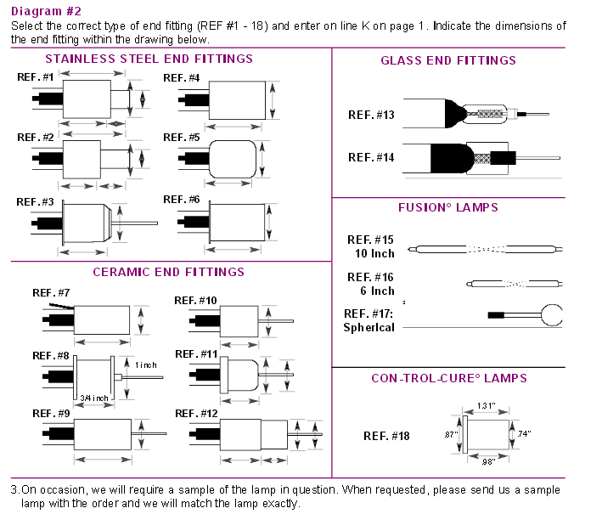

Lamp Details:

Contact:

Company:

Address:

Email Address:

Telephone Number:

Purchase Quantity (This Order):

Purchase Quantity (Approx. Per Year):

